09/14/25
Module 3: Systems Thinking in Data Visualization

Part One: What is System 1 and 2 Thinking?
System 1 mode of cognitive processing (pre-attentive):
- Fast
- Automatic
- Subconscious
- No voluntary control (gut instinct)
- Little to no effort
- Useful to make quick decisions and judgements
Example: orient to the source of a sudden sound
In visualization: brain’s first impression
System 2 mode of cognitive processing (attentive):
- Slow
- Analytical
- Conscious
- Voluntary control
- Takes effort
- Used for complex problem-solving and analytical tasks
Example: focus on the voice of a particular person in a crowded room
In visualization: activated when you analyze what you’re looking at
Trigger system 1 thinking as much as possible
Part Two: Activating System 1 and System 2 Thinking
How to activate system 1 thinking in your data viz
- Focus on clarity and simplicity: visuals that are easy to interpret at a glance
- Use recognizable icons and symbols: tap into associations that viewers already recognize
- To highlight information, use pre-attentive attributes
- To emphasize patterns and organize information, use Gestalt principles of visual perception
Pre-attentive attributes: visual elements like color, shape, size and position to highlight important information and guide the viewer’s eye
Employ gestalt principles of visual perception:
- States that brains are programmed to detect patterns
- Leverage the following principles of perception to organize visual information into patterns easily apparent by the human brain
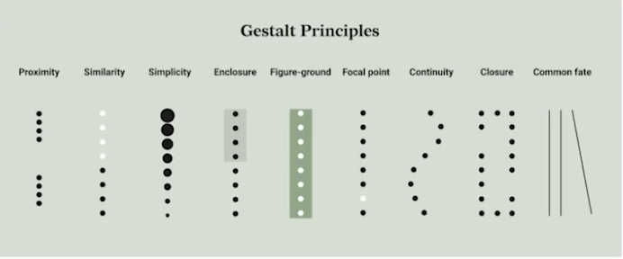

Use system 2 activation when the purpose is to make comparisons, consider cause and effect relationships, or encourage deeper exploration and understanding
- Provide context and background information
- Offer interactive elements
- Encourage comparison and analysis
- Communicate uncertainty and variation with confidence intervals and error bars
- Reduce clutter and have selective annotations
- Consider graph literacy of your target audience
- Consider the brain’s working memory
  - Human short-term memory can only store 5 items at once and maintain information for a few seconds
System 1 and 2 thinking work in tandem to guide decision-making and understanding
Effective data visualization involves leveraging both systems
Interactive dashboards do just that!

When to prioritize system 1 thinking: public-facing infographics or to signal alerts to elicit emotional reactions
When to leverage both systems of thinking: exploratory data analysis, technical reports, training and education tools, dashboards for monitoring and decision-making

